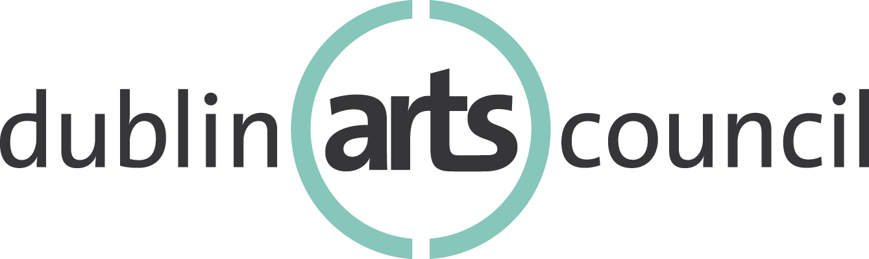
Community Arts Grant Program
2022 Application Procedures

Program Objectives

Dublin Arts Council’s Community Arts Grants demonstrate a continued commitment to support and invest in the arts in Dublin. By granting funds to nonprofit arts organizations and supporting arts projects with primary impact in Dublin, we strive to ensure a healthy community in which a variety of art forms, arts organizations and artistic projects can flourish.

Community Arts Grants provide support for single or a series of high-quality arts and cultural activities. Grants support a myriad of arts-related programing, including visual, media, literary and folk arts; festivals; artists’ series; arts and cultural programs; public art programs; among others.

Eligibility Criteria

In order to apply, organizations must meet the following criteria. Applicants who do not meet these criteria will not be considered for funding.

Applicants:
- Must be exempt under section 501 (c) (3) of the Internal Revenue Service and registered with the State of Ohio as a non-profit organization
- Proposed project must have a primary impact in Dublin
- Projects must take place from January 1, 2022 – December 31, 2022
- Must align with Dublin Arts Council’s mission: Dublin Arts Council engages the community, cultivates creativity and fosters life-long learning through the arts
- Must adhere to Dublin Arts Council’s anti-discrimination policy: Dublin Arts Council celebrates and recognizes the contributions of people of different races, gender, nationalities, ages and religions have made to the world of art. Discrimination on the basis of race, gender, sexual orientation, nationality, age or religion will not be tolerated.
- Must submit accurate budgets that are appropriate to the proposed project or creative work and reflect need for financial support
- Should not look to Dublin Arts Council as the only form of financial support
- Repeat applicants must be compliant and in good standing with regard to previous Community Arts Grants guidelines and final reporting mandates.

Review Criteria

A review committee evaluates the application’s strengths and weaknesses and provides comments – based on the criteria in the scoring categories below. Each criterion is worth up to ten points, for a maximum of 100 points.

Project Quality & Artistic Vibrancy: (20 points)
- The project is an outstanding example of engaging and high-quality artistic/cultural activities.
- Persons involved demonstrate a history of achievement and experience relevant to the project.

Community Engagement & Impact: (50 points)
- Project goals are clearly defined, and align with Dublin Arts Council’s mission.
- Project activities exemplify preferred criteria: 1) providing education; 2) enriching the community; 3) developing audiences; and/or 4) supporting artists
- Project engages participants in a deep and meaningful way, with primary impact in Dublin.
- Quality of marketing/promotional efforts reach targeted audiences and promote accessibility.
- Evaluation method(s) is thorough and effectively measures project impact.

Resource Management: (30 points)
- A clear plan for project implementation is defined.
- Financial documents (Income & Expense Statement, Balance Sheet, In-Kind Support) are accurate, aligned with proposal narrative, and offer multiple forms of financial support above and beyond Dublin Arts Council support.
- Organization has thought considerably about project adaptation, accessibility and contingency planning in the event COVID-19 continues to present an issue.

Application Procedure

PHASE 1 – Application deadline is Thursday, November 18, 2021 by 5 p.m.
Please submit one copy of the application form and supporting documentation:

- By mail: Dublin Arts Council, 7125 Riverside Drive, Dublin, Ohio 43016; Attn: Dr. David Guion

- Or by email: Katy Marque, Education & Development Manager at marque@dublinarts.org.

The application form, a sample income and expense report (budget) and sample balance sheet can be accessed on the DAC website as PDFs or as Word/Excel documents. https://dublinarts.org/news/grants/

PHASE 2 – Committee review & board approval
All applications are reviewed and scored by the Community Arts Grants Review Committee, which is comprised of Dublin Arts Council board members. Committee members make funding recommendations to the full board based on their review and the amount of funding available. Recommendations will be reviewed and approved by Dublin Arts Council’s Board of Directors.

PHASE 3 – Award notification
Following board approval, applicants will receive written notification of the results along with panel comments in January/February 2022. If funding of a Community Arts Grant is approved, payment is remitted after the organization has met with DAC staff and has signed a grantee agreement.

PHASE 4 – Final reporting
A final report will be due following conclusion of the project for which funding is provided no later than Thursday, February 9, 2023 at 5 p.m. This final report should include:
- Documentation of how funds were spent
- Detailed description of activities, including reach and attendance figures
- Examples of publications/collateral that demonstrate use of the Dublin Arts Council logo and/or verbal/written credit of Dublin Arts Council's support
- A sample evaluation tool and summary of data
- One to two project photos (JPEG or PNG)

Failure to submit the grant final report in a timely and complete manner will result in the denial of future grant applications.

Contact

For questions and inquiries, please contact Katy Marque, Education & Development Manager, via email at marque@dublinarts.org or by phone at 614-889-7444.

